Q1. Agile projects deliver high-quality products, which to some degree, are managed by effective problem detection and resolution. Which tools and techniques are applied in order for Agile teams to deliver high quality and briefly explain the techniques?[4]

Q2. You are taking on the role of Scrum master of an Agile team. Several team members have been removed because they didn’t deliver and had a bad attitude. Now team members are not showing up for meetings, the team is running low in each sprint, and the product owner complains that working with them is a hassle and the quality of their work is low. What could be the possible problem with the team and what can you do?[2]

Q3. The process found in the following table has an efficiency of 76% (490/640) with 490 minutes of value and 150 minutes of waste.  Draw the Value Stream Map of the current state of the process? How would you improve on this process?[4]

|  |  |  |
| --- | --- | --- |
| **Activities** | **Value** | **Waste** |
| Request | 5 minutes |  |
| E-mail supervisor |  | 15 minutes |
| Approve | 5 minutes |  |
| E-mail to tech-lead | 2 hours |  |
| Assign team |  | 1 hour |
| Code and test | 4 hours |  |
| To verification |  | 30 minutes |
| Verify | 1 hour |  |
| To operations |  | 30 minutes |
| Deploy | 1 hour |  |

Q4. Your customer has following customer satisfaction issues.

a. Product requirements misunderstood by the development team

b. The customer can’t request changes without additional cost and time.

c. The product wasn’t delivered when the customer needed it.

Explain how by adapting Agile approaches, these issues can be addressed more effectively? [3]

Q5. In order to develop team collaboration and commitment it may be necessary to reduce distractions in order to establish a predictable outcome and optimize the value delivered. The following table contains the roles found in Scrum. Explain what each role should do in order to reduce distractions.                                                     [3]

|  |  |
| --- | --- |
| **Role** | **How to Reduce Distractions?** |
| The Team |  |
| The Scrum Master |  |
| The Product Owner |  |

Q6. Questions during daily standup meetings: Which of the following is valid during daily standup meetings and why?   [2]

1. Our new contractor can’t start because no one is here to sign the contract.

2. The department manager has asked me to work for another team for the remaining week.

3. I tested story number 10 yesterday.

4. I still haven’t received the software I ordered a month ago.

5. You discuss the football match since it involves a bet between several team members.

6. I’m struggling to learn C++ and would like to pair with someone on it.

7. I can’t get the product owner to show up or call me back.

8. You explain why a team member should be removed from the team.

Q7. Write a User Story for Agile Conference in the following format:

The format for this exercise is: As a <type of user>, I want <to perform some task> so that I can <achieve some goal/benefit/value>                  [2]

|  |
| --- |
| Q8. Your team is starting to use story point estimation for the first time, How do they know how many  story points to assign to a story?   [2] |
|  |

Q9. In the past, your team has run projects using a more formal Waterfall method and now incorporating Agile methodologies. What are the biggest differences in how you manage your projects?[4]

Q10. [3]   
  
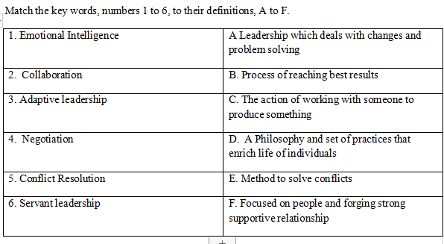

|  |
| --- |
| Q11. What’s the difference between the Product Backlog and the Sprint Backlog?  [2] |
|  |

Q12. ABC Corporation has received the contracts from the customer to execute the following types of software projects.

Project-A: A mission critical software development project with adherence to external regulatory compliance. In this project the customer has committed upfront to provide the detailed product requirements. These requirements are reviewed and approved. The customer does not expect any major change in scope during the execution of the project.

Project-B:  An emerging e-commerce development project. In this project the customer has committed upfront to provide high level requirements. These requirements are evolving and subject to change during the project.

In both the projects, the customer is expecting the delivery of the working product only at the end of the project and has agreed to collaborate, review and provide feedback whenever required. The expected duration of these projects is around 6 months and you may assume adequate resources are available for both the projects.

As an Agile consultant, what is the project life cycle method best suitable for each type of project and explain the rationale behind in choosing the life cycle method? What are the development phases involved in each life cycle method?[4]